**COMSATS UNIVERSITY ISLAMABAD**



**SUBMITTED BY**

**NAME:** NOOR UL AIN

**REG. NO.:** FA19-BSE-168

**SECTION:** BSE-7C

**SUBMITTED TO**

**TEACHER:** Ms. MAMUNA FATIMA

**SUBJECT:** DATA WAREHOUSING & DATA MINING

**LAB TASK # 07**

**Lab Tasks:**

1. Write purpose of numpy, pandas and sklearn library in your own words.

# Numpy

NumPy stands for ‘Numerical Python’ or ‘Numeric Python’. It is an open-source module of Python which provides fast mathematical computation on arrays and matrices.

# Pandas

[**Pandas**](http://pandas.pydata.org/)is a Python library for data analysis. Pandas is built on top of two core Python libraries—[**matplotlib**](https://mode.com/python-tutorial/libraries/matplotlib) for data visualization and [**NumPy**](https://mode.com/python-tutorial/libraries/numpy) for mathematical operations.

# Sklearn

Scikit-learn (formerly scikits. learn and also known as sklearn) is **a free software machine learning library for the Python programming language**.

1. Understand the code above and write the purpose of each code statement in your own words.
2. 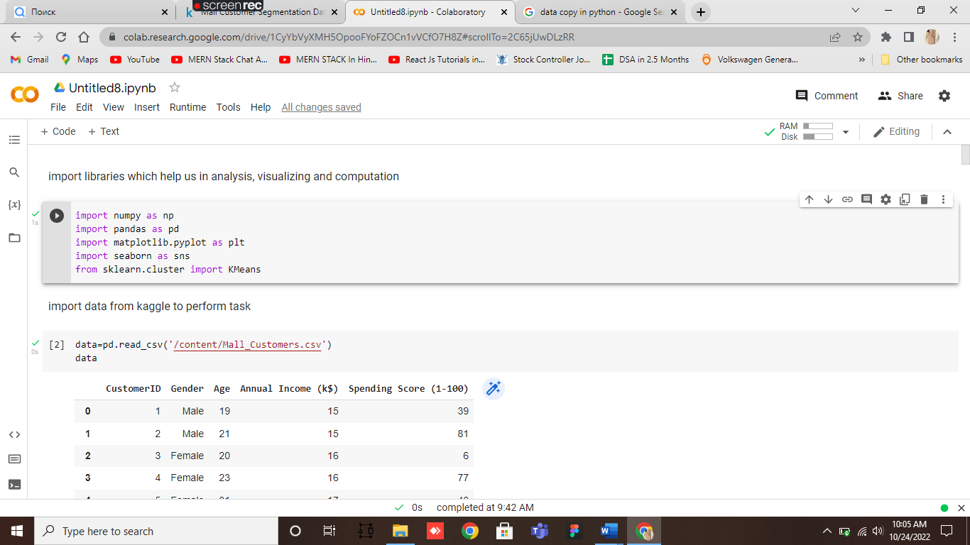Execute the above code with provided data.

